EX#1 – LIENHARD 1.2 + ADAPTATION – Metal Slab Transient and Steady State Analysis

A metal slab consisting of 3mm thick copper protected by 2mm steel on both sides has a boundary temperature of 400℃ on one side of the wall (Th) and 100℃ on the other side of the wall (Tl). The initial temperature of the composite slab (To) is 400℃. The

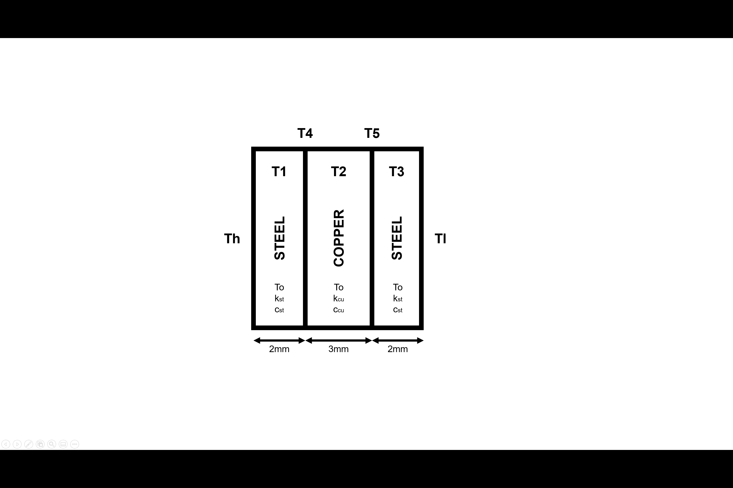

*Fig. 1, The Schematic of the Walls in Series*

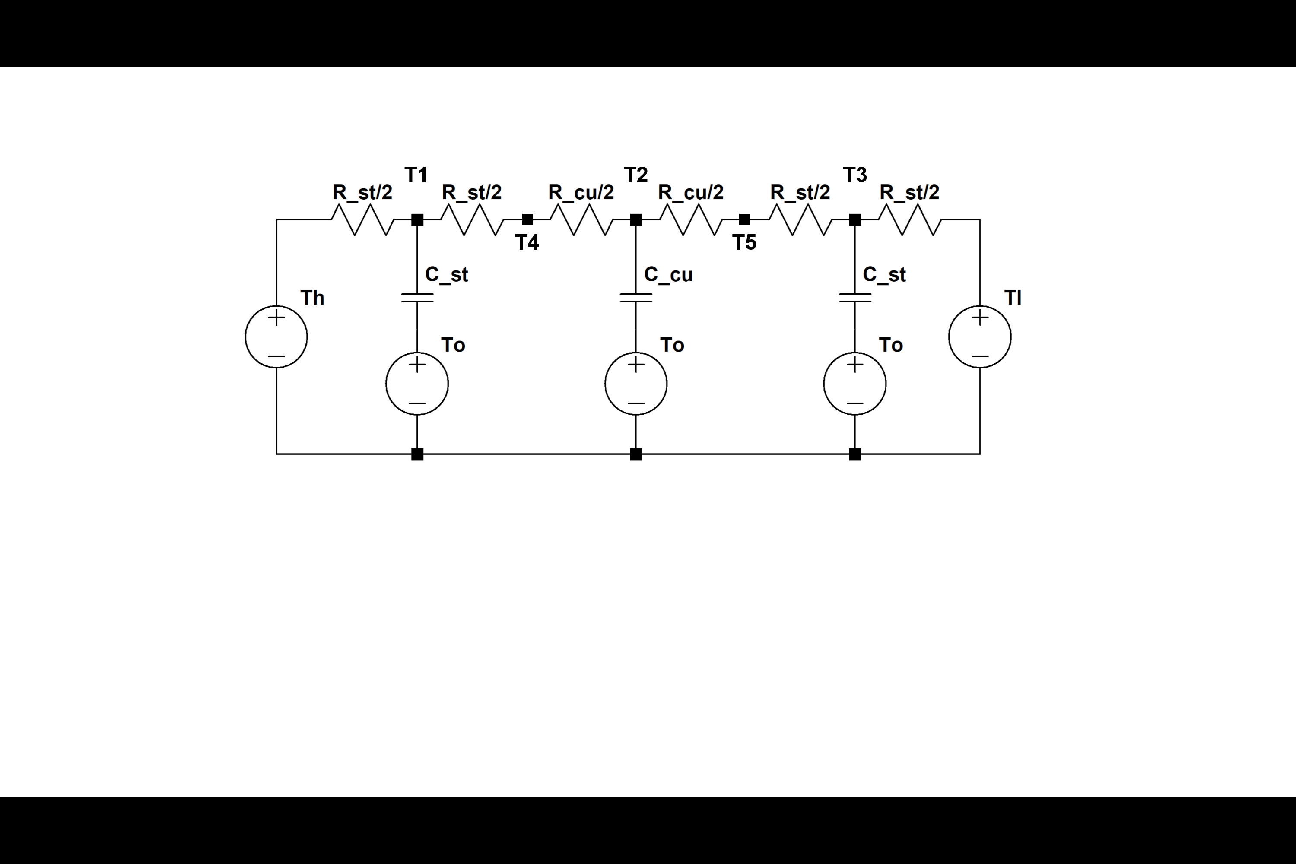

*Fig. 2, The Circuit Diagram of the Walls in Series*

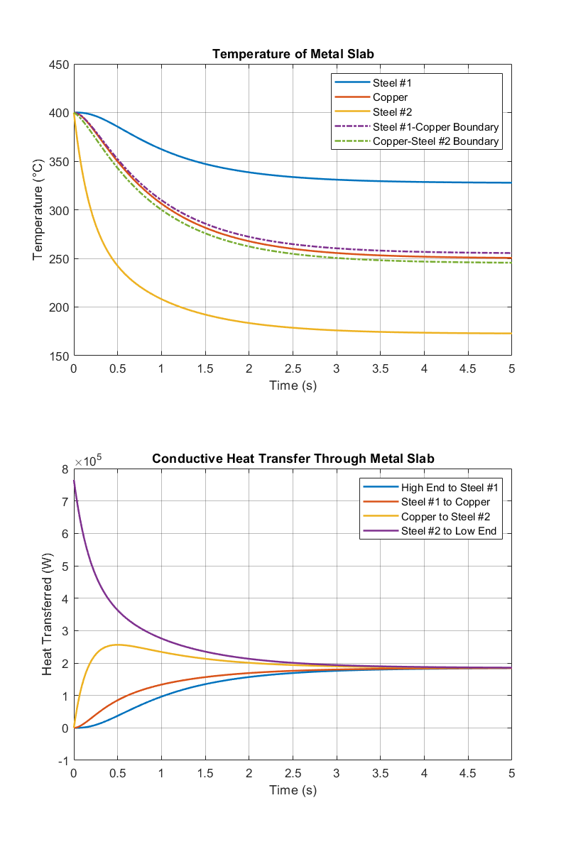

*Fig. 3, The Resulting Heat Transfer and Temperature Change at Different Nodes of the Circuit for the Walls in Series*

a)

It takes approximately about 3 seconds for the system to reach a steady state. The result estimated from the heat transfer diagram matches with the one estimated from the temperature diagram.

b)

The temperatures for the boundaries from left to right between different metal walls calculated during the class exercise are 254.9 degree Celsius and 245.06 degree Celsius. These values perfectly match with the boundary temperatures plotted in fig.3 when capacitors are presented in the circuit. The result makes sense because the capacitors will not influence the steady state result of the thermal circuit.

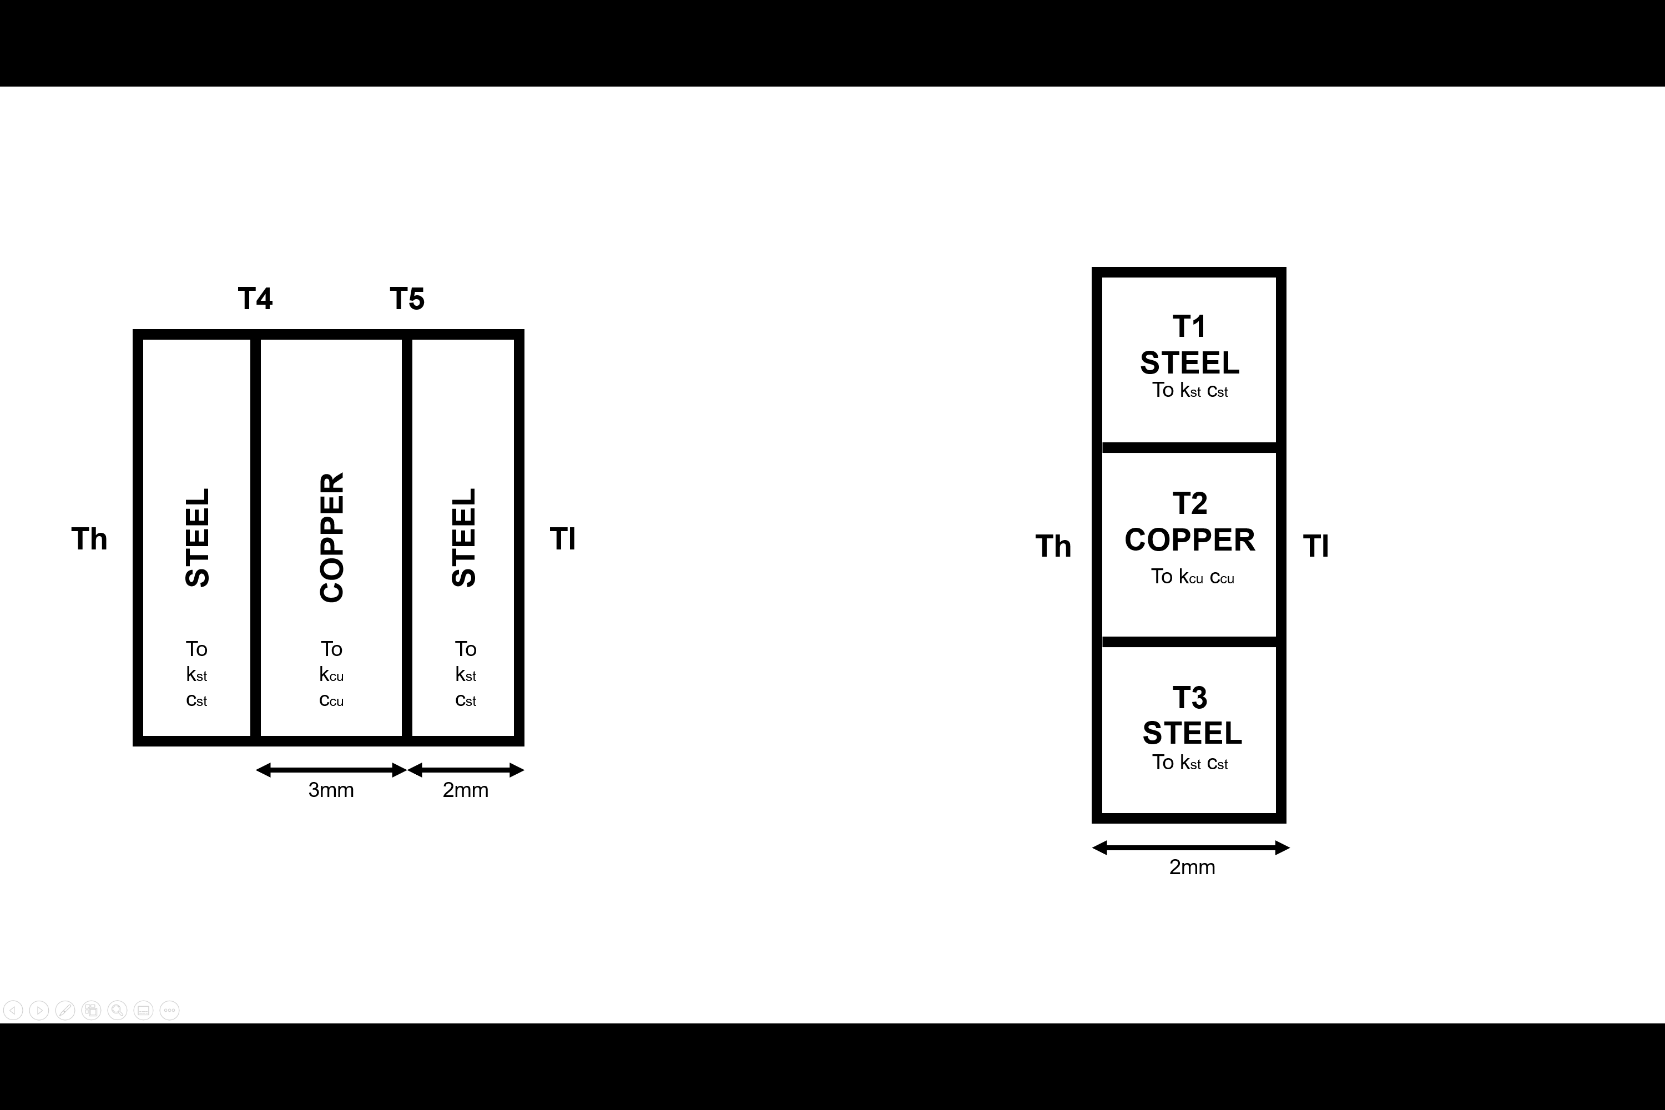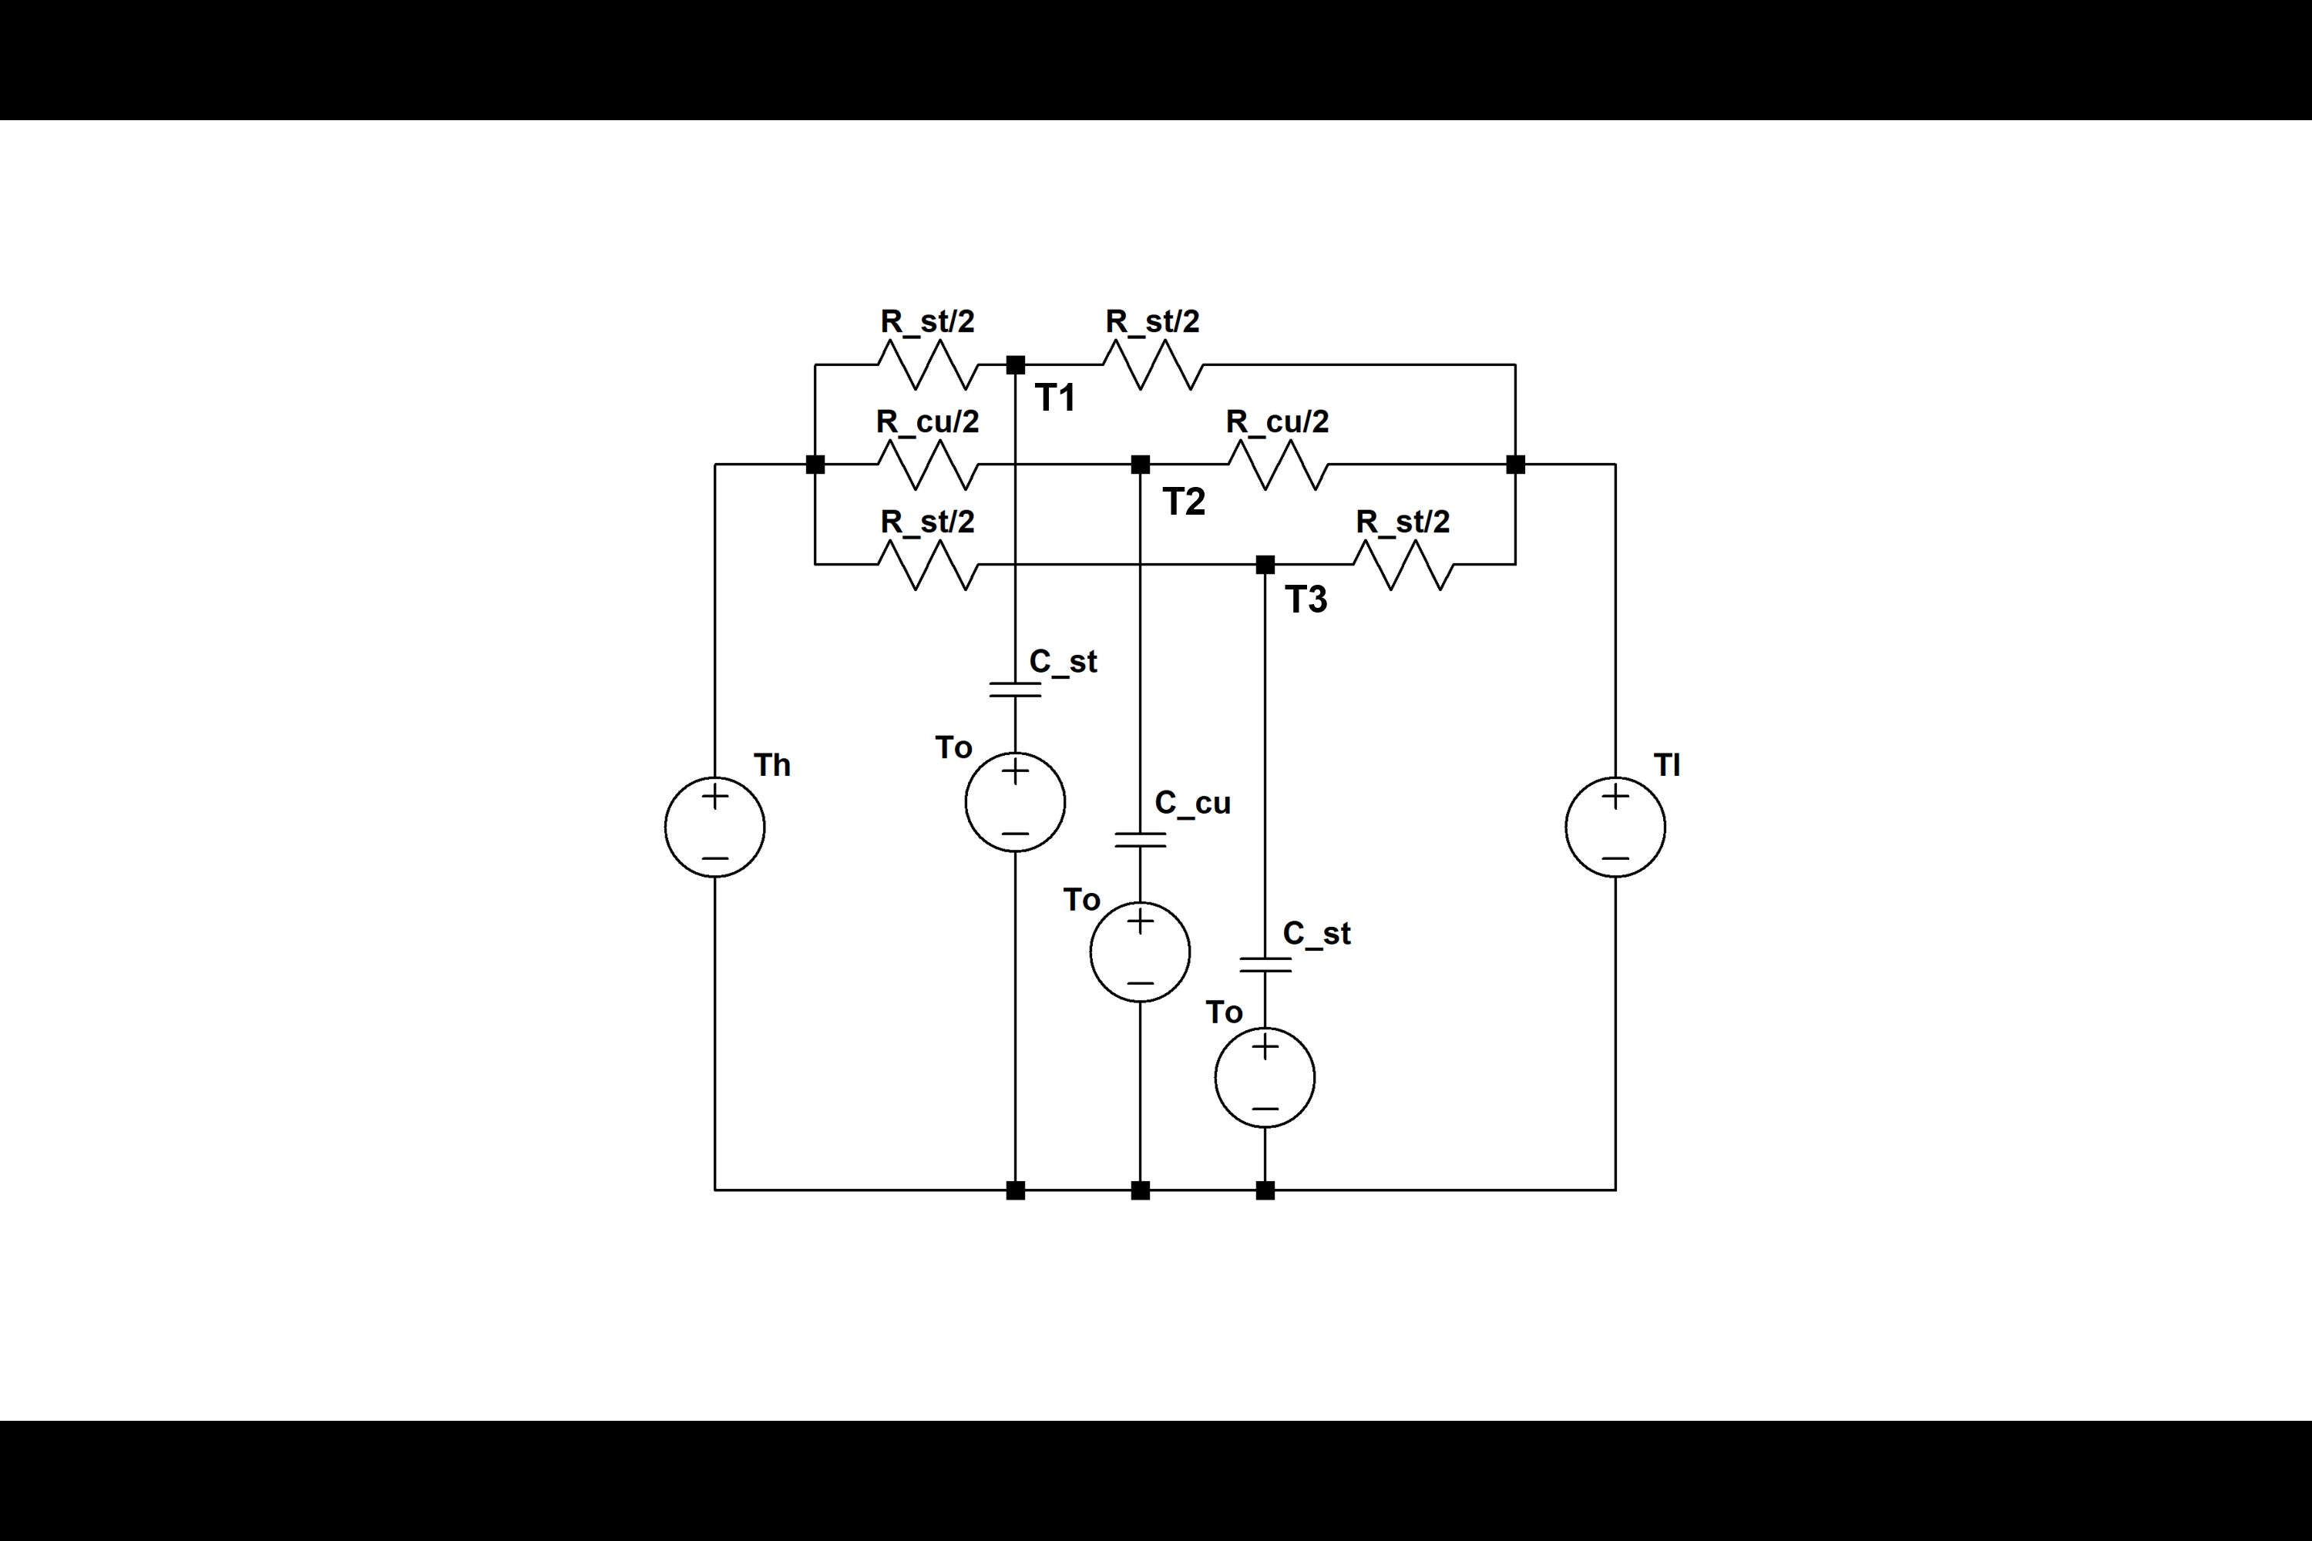

*Fig. 4, The Schematic and the Circuit Diagram of the Walls in Parallel*

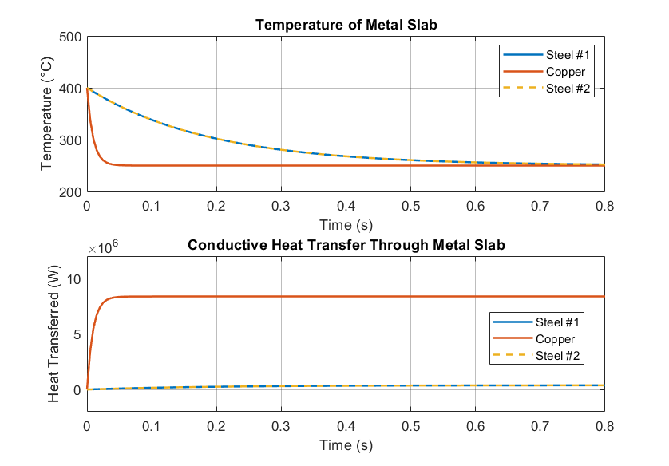

*Fig. 5, The Resulting Heat Transfer and Temperature Change at Different Nodes of the Circuit for the Walls in Parallel*

1. It takes approximately 0.03 seconds for the Copper wall to reach a steady state, and it takes about 0.6 seconds for the steel walls to reach their steady state. The result estimated from the heat transfer diagram matches with the one estimated from the temperature diagram.
2. The steady-state temperature of the system is 250 degree Celsius, which matches with the resulted calculated during the class exercise. This is because in the long run, the effect of the capacitor died out, and the system will behave like a circuit with only voltage source and resistances.

EX#2 – HW2 Revisited – Thermal circuit analysis of a simple RC circuit with Forcing Temperature

An iron block of mass 200 kg with a temperature of 300℃ (573.15 K) is cooling in a room with ambient temperature 25sin(pi*t/60)+298.1

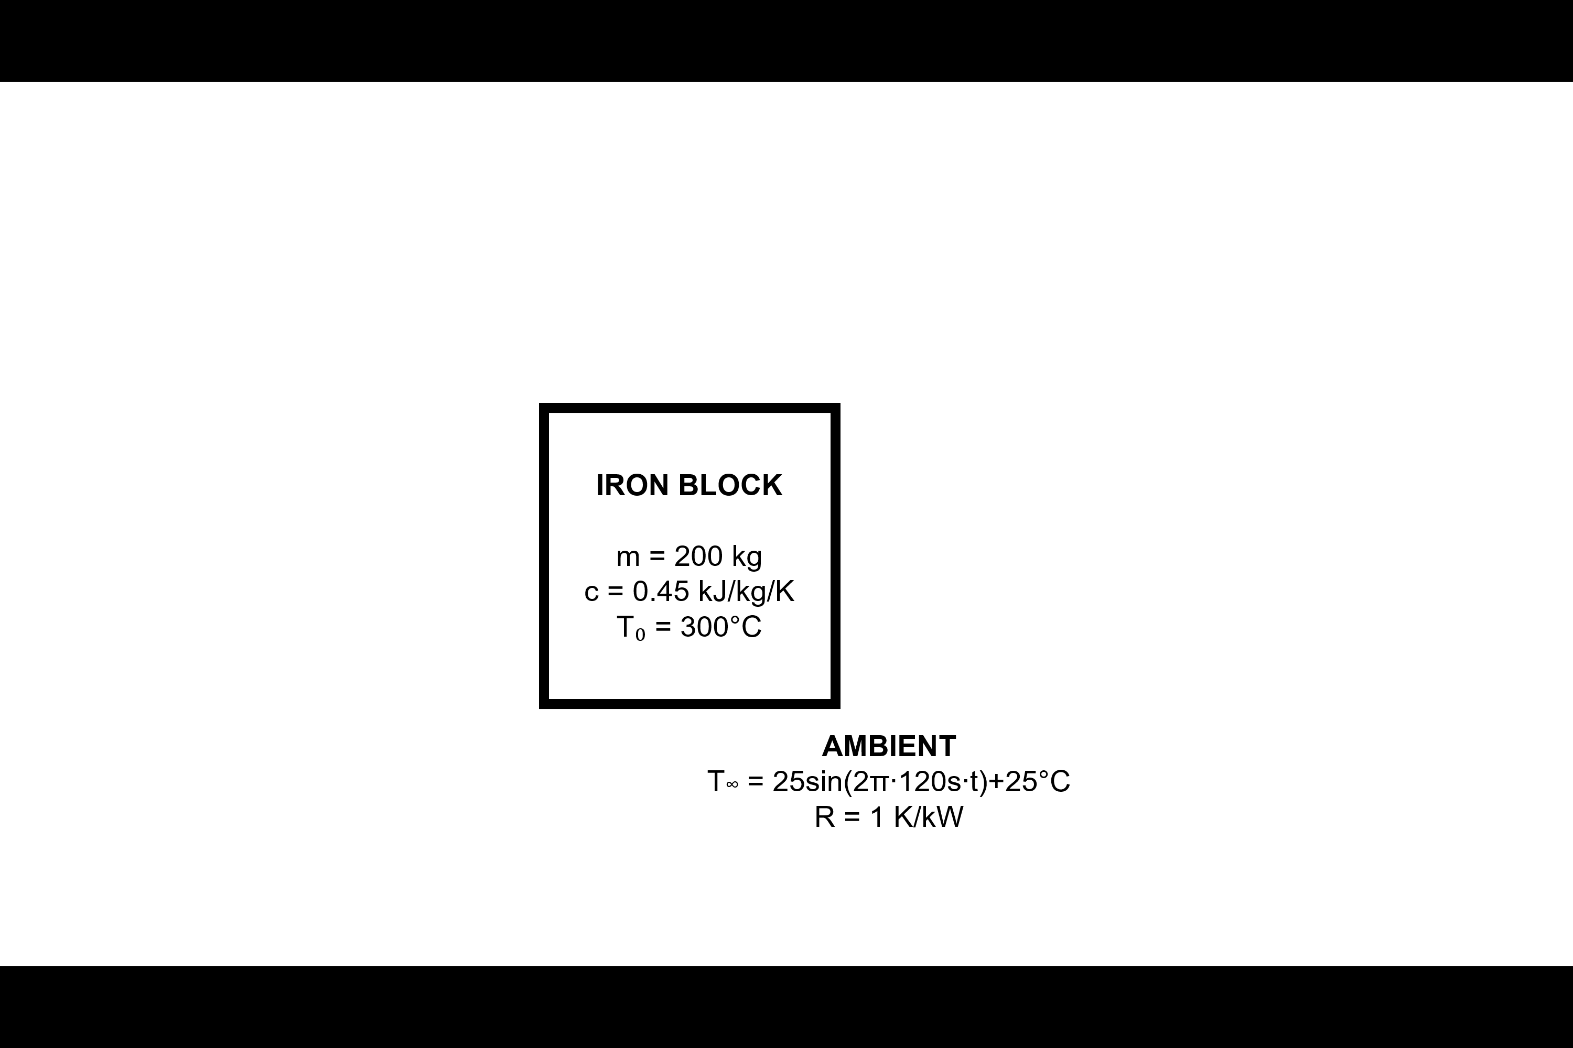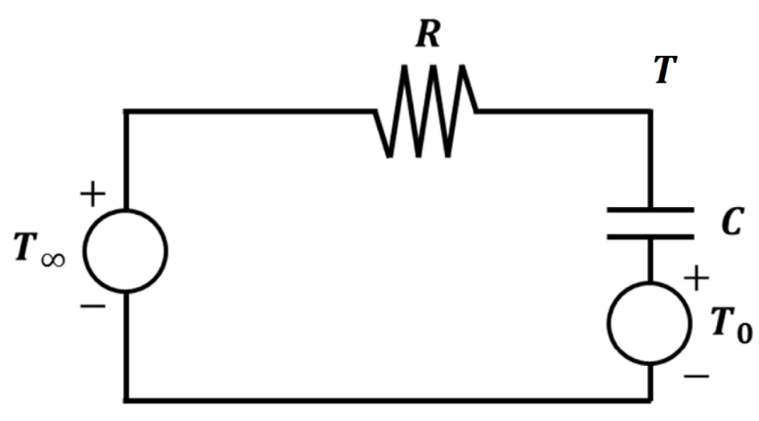

*Fig. 7, An Iron Block Cooling in a Room, followed by Heat Transfer Circuit of the System*

The time domain function of the environment driving temperature is transferred into Laplace domain

The calculated impulse response of the driving function is verified by plotting its impulse response in Matlab, the resulting graph is given as below, which matches with the driven temperature function.

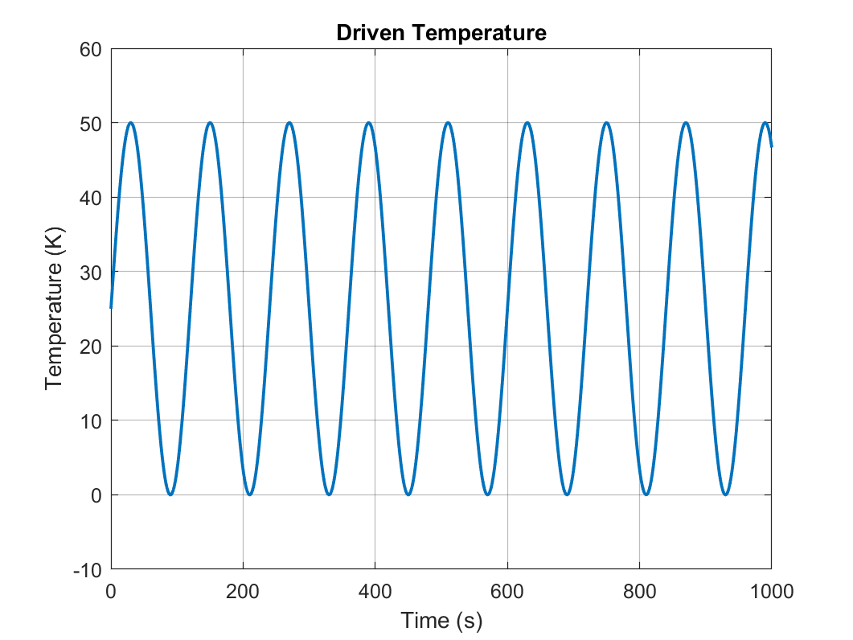

*Fig. 8, The Driven Temperature Applied to The Iron Block*

a)

Using the circuit model set up previously, the impulse response of the temperature and heat transfer of the iron block is shown below (Fig. 8, see code in Appendix).

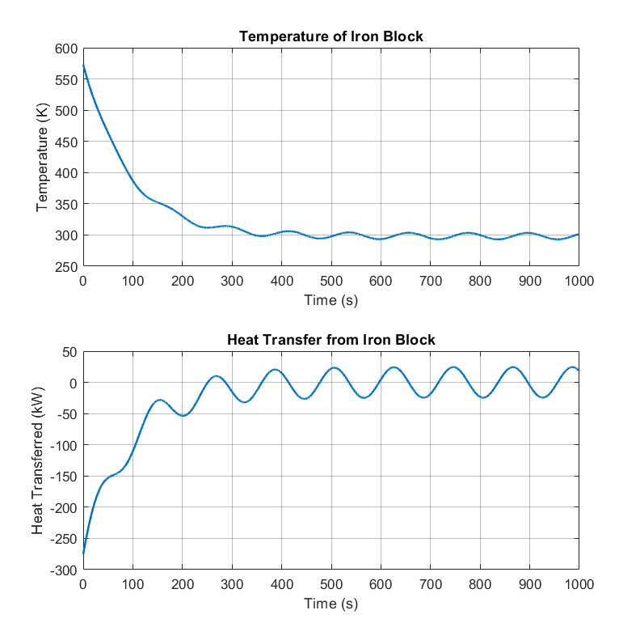

*Fig. 8, The Resulting Heat Transfer and Temperature Change of the Iron Block*

b)

To observe the temperature and heat transfer responses of the iron block under different resistances with the sinusoidal driven temperature, a FOR loop is ran to output the responses (see Appendix). The resistances chosen were 0, 1, 2.5, 5, and 10 K/kW. The temperature and heat transfer responses are shown below (Fig. 9).

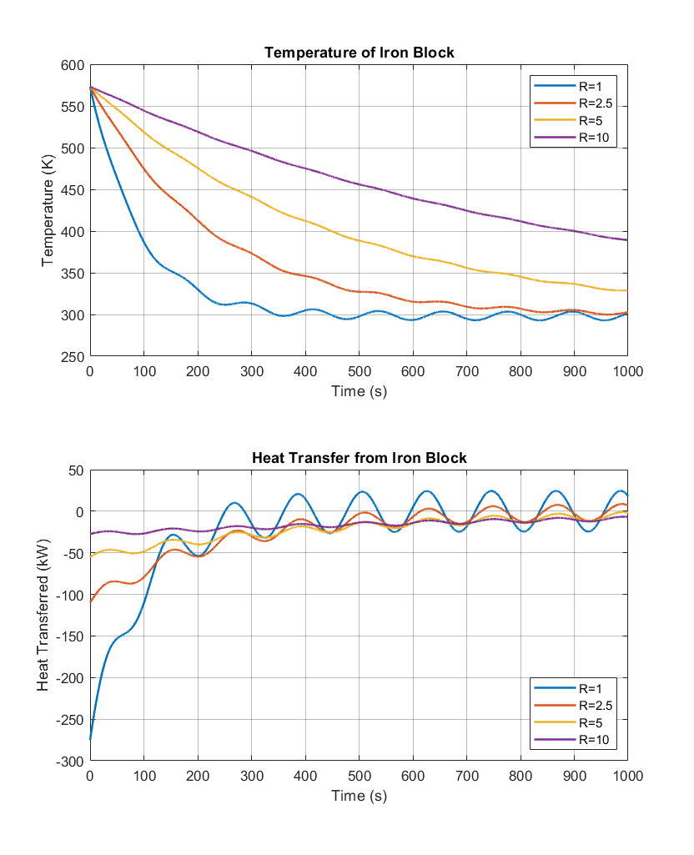

*Fig. 9, The Resulting Heat Transfer and Temperature Change of the Iron Block with Varying R Values*

c)

The time it takes for the iron block to reach an average temperature of about 298.15 K increases as the resistance value is increased. It also takes longer for the heat transfer rate to reach an average value of 0. This makes perfect sense, since it is harder for heat to transfer from the iron block to the environment when there exists a higher resistance. According to the graph, the temperatures of the block will eventually follow a sinusoidal pattern as it reaches the transient state. The steady state response for both the heat transfer rate and the temperature adopted the period of the driven function but shows varied amplitudes.

APPENDIX

%% ME342_HW2_20200212

%% EX#1 - 2.1

A = 0.3*0.5;

R_st = 0.002/17/A;

R_cu = 0.003/372/A;

C_st = 0.002*A*8000*400; %thickness*area*rho*c

C_cu = 0.003*A*8954*384;

Th = 400+273.15;

To = 400+273.15;

Tl = 100+273.15;

t = [0:0.01:5];

s = tf('s');

Y = [(-2/R_st-2/(R_st+R_cu)-s*C_st), 2/(R_st+R_cu), 0, 0, 0;

2/(R_st+R_cu), (-2*2/(R_st+R_cu)-s*C_cu), 2/(R_st+R_cu), 0, 0;

0, 2/(R_st+R_cu), (-2/R_st-2/(R_st+R_cu)-s*C_st), 0, 0;

2/R_st, 2/R_cu, 0, (-2/R_st-2/R_cu), 0;

0, 2/R_cu, 2/R_st, 0, (-2/R_st-2/R_cu)];

F = [-s*C_st*To/s-2*Th/s/R_st;

-s*C_cu*To/s;

-s*C_st*To/s-2*Tl/s/R_st

0;

0];

T = Y\F;

Q = [(Th/s-T(1))*2/R_st;

(T(1)-T(2))*2/(R_st+R_cu);

(T(2)-T(3))*2/(R_st+R_cu);

(T(3)-Tl/s)*2/R_st];

temp = impulse(T,t)-273.15;

q = impulse(Q,t);

figure(1)

subplot(2,1,1)

plot(t,temp(:,1),t,temp(:,2),t,temp(:,3),t,temp(:,4),'-.',t,temp(:,5),'-.','LineWidth',1.5)

title('Temperature of Metal Slab','FontSize',16)

xlabel('Time (s)','FontSize',12)

ylabel('Temperature (K)','FontSize',12)

set(gca,'FontSize',10)

grid on

set(gca,'GridAlpha',0.3)

legend('Steel #1','Copper','Steel #2','Steel #1-Copper Boundary','Copper-Steel #2 Boundary','Location','northeast')

subplot(2,1,2)

plot(t,q,'LineWidth',1.5);

title('Conductive Heat Transfer Through Metal Slab','FontSize',16)

xlabel('Time (s)','FontSize',12)

ylabel('Heat Transferred (J)','FontSize',12)

set(gca,'FontSize',10)

grid on

set(gca,'GridAlpha',0.3)

legend('High End to Steel #1','Steel #1 to Copper','Copper to Steel #2','Steel #2 to Low End','Location','northeast')

%% EX#1 - 2.2

A = 0.3*0.5;

R_st = 0.002/17/A;

R_cu = 0.003/372/A;

C_st = 0.002*A*8000*400; %thickness*area*rho*c

C_cu = 0.003*A*8954*384;

Th = 400+273.15;

To = 400+273.15;

Tl = 100+273.15;

t = [0:0.01:1.5];

s = tf('s');

Y = [-4/R_st-s*C_st 0 0;

0 -4/R_cu-s*C_cu 0;

0 0 -4/R_st-s*C_st];

F = [-s*C_st*To/s-2*(Th+Tl)/s/R_st;

-s*C_cu*To/s-2*(Th+Tl)/s/R_cu;

-s*C_st*To/s-2*(Th+Tl)/s/R_st];

T = Y\F;

Q = [(Th/s - T(1))*2/R_st;

(Th/s - T(2))*2/R_cu;

(Th/s - T(3))*2/R_st];

temp = impulse(T,t);

q = impulse(Q,t);

figure(1)

subplot(2,1,1)

plot(t,temp(:,1),t,temp(:,2),t,temp(:,3),'--','LineWidth',1.5)

% ylim([250 600])

title('Temperature of Metal Slab','FontSize',16)

xlabel('Time (s)','FontSize',12)

ylabel('Temperature (K)','FontSize',12)

set(gca,'FontSize',10)

grid on

set(gca,'GridAlpha',0.3)

legend('Steel #1','Copper','Steel #2','Location','northeast')

subplot(2,1,2)

plot(t,q(:,1),t,q(:,2),t,q(:,3),'--','LineWidth',1.5)

% ylim([-300 50])

title('Conductive Heat Transfer Through Metal Slab','FontSize',16)

xlabel('Time (s)','FontSize',12)

ylabel('Heat Transferred (J)','FontSize',12)

set(gca,'FontSize',10)

grid on

set(gca,'GridAlpha',0.3)

legend('Steel #1','Copper','Steel #2','Location','northeast')

%% EX#2

%% SETUP

R = 1; % K/kW

c = 0.45; % kJ/kg/K

m = 200; % kg

C = m*c; % kJ/K

dt = 0.1; % s

t_fin = 1000; % s

t = [0:dt:t_fin].';

T_inf = 25+273.15; % K

f = 2*pi/120;

T0 = 300+273.15; % K

s = tf('s');

F = [25*f/(f^2+s^2) + T_inf/s - T0/s];

Z = [R(ii)+1/s/C];

Q = Z\F;

T = 25*f/(f^2+s^2) + T_inf/s - R(ii)*Q;

temp = impulse(T,t);

q = impulse(Q,t);

figure(1)

subplot(2,1,1)

plot(t,temp,'LineWidth',1.5)

ylim([250 600])

title('Temperature of Iron Block','FontSize',16)

xlabel('Time (s)','FontSize',12)

ylabel('Temperature (K)','FontSize',12)

set(gca,'FontSize',10)

grid on

set(gca,'GridAlpha',0.3)

subplot(2,1,2)

plot(t,q,'LineWidth',1.5);

ylim([-300 50])

title('Heat Transfer from Iron Block','FontSize',16)

xlabel('Time (s)','FontSize',12)

ylabel('Heat Transferred (J)','FontSize',12)

set(gca,'FontSize',10)

grid on

set(gca,'GridAlpha',0.3)

%% VARIABLE RESISTANCE

R = [1 2.5 5 10]; % K/kW

c = 0.45; % kJ/kg/K

m = 200; % kg

C = m*c; % kJ/K

dt = 0.1; % s

t_fin = 1000; % s

t = [0:dt:t_fin].';

T_inf = 25+273.15; % K

f = 2*pi/120;

T0 = 300+273.15; % K

s = tf('s');

F = [25*f/(f^2+s^2) + T_inf/s - T0/s];

for ii = 1:length(R)

Z = [R(ii)+1/s/C];

Q = Z\F;

T = 25*f/(f^2+s^2) + T_inf/s - R(ii)*Q;

temp = impulse(T,t);

q = impulse(Q,t);

figure(1)

subplot(2,1,1)

plot(t,temp,'LineWidth',1.5)

ylim([250 600])

title('Temperature of Iron Block','FontSize',16)

xlabel('Time (s)','FontSize',12)

ylabel('Temperature (K)','FontSize',12)

set(gca,'FontSize',10)

grid on

set(gca,'GridAlpha',0.3)

legend('R=1','R=2.5','R=5','R=10','Location','southwest')

hold on

subplot(2,1,2)

plot(t,q,'LineWidth',1.5);

ylim([-300 50])

title('Heat Transfer from Iron Block','FontSize',16)

xlabel('Time (s)','FontSize',12)

ylabel('Heat Transferred (J)','FontSize',12)

set(gca,'FontSize',10)

grid on

set(gca,'GridAlpha',0.3)

legend('R=1','R=2.5','R=5','R=10','Location','southeast')

hold on

end

%% EX#2

R=1;

C=0.45*200;

B2=((pi*5/12)/(s^2+(pi*1/60)^2))+(25/s)-(300/s);

A2=R+(1/(s*C));

x_s3=A2\B2;

% x_t3=ilaplace(x_s3);

t_final=1000;

dt=0.01;

t=(0:dt:t_final).';

x_t3=impulse(x_s3,t);

% Verifying the calculated laplace domain driven function

Df=impulse((pi*5/12)/(s^2+(pi*1/60)^2)+(298.15/s),t);

figure(5)

plot(t,Df,'LineWidth',1.5)

title('Driven Temperature','FontSize',14)

xlabel('Time (s)','FontSize',12)

ylabel('Temperature (K)','FontSize',12)

set(gca,'FontSize',10)

grid on

set(gca,'GridAlpha',0.3)

% Ex#2 part b)

figure(1)

plot(t,x_t3,'LineWidth',1.5)

title('Heat Transfer of Iron Block','FontSize',14)

xlabel('Time (s)','FontSize',12)

ylabel('Heat Transfer Rate (J/s))','FontSize',12)

set(gca,'FontSize',10)

grid on

set(gca,'GridAlpha',0.3)

T=((pi*5/12)/(s^2+(pi*1/60)^2))+(25/s)-R*x_s3+(273.15/s);

figure(2)

T_t3=impulse(T,t);

plot(t,T_t3,'LineWidth',1.5)

title('Temperature of Iron Block','FontSize',14)

xlabel('Time (s)','FontSize',12)

ylabel('Temperature (K)','FontSize',12)

set(gca,'FontSize',10)

grid on

set(gca,'GridAlpha',0.3)

%% Ex#2 part c)

for R=[0,1,2.5,5,10]

B2=((pi*5/12)/(s^2+(pi*1/60)^2))+(25/s)-(300/s);

A2=R+(1/(s*C));

x_s3=A2\B2;

t_final=1000;

dt=0.01;

t=(0:dt:t_final).';

x_t3=impulse(x_s3,t);

figure(3)

plot(t,x_t3,'LineWidth',1.1)

title('Heat Transfer of Iron Block with Varying R','FontSize',14)

xlabel('Time (s)','FontSize',12)

ylabel('Heat Transfer rate (J/s)','FontSize',12)

set(gca,'FontSize',10)

grid on

set(gca,'GridAlpha',0.3)

legend({'R=0','R=1','R=2.5','R=5','R=10'},'Location','southeast')

hold on

end

for R=[0,1,2.5,5,10]

B2=((pi*5/12)/(s^2+(pi*1/60)^2))+(25/s)-(300/s);

A2=R+(1/(s*C));

x_s3=A2\B2;

t_final=1500;

dt=0.01;

t=(0:dt:t_final).';

T=((pi*5/12)/(s^2+(pi*1/60)^2))+(25/s)-R*x_s3+(273.15/s);

figure(4)

T_t3=impulse(T,t);

plot(t,T_t3,'LineWidth',1.1)

title('Temperature of Iron Block','FontSize',14)

xlabel('Time (s)','FontSize',12)

ylabel('Temperature (K)','FontSize',12)

set(gca,'FontSize',10)

grid on

set(gca,'GridAlpha',0.3)

legend({'R=0','R=1','R=2.5','R=5','R=10'},'Location','northeast')

hold on

end